System and Software Architecture Description (SSAD)

Combat Conflict

Team Number 4

Team members and roles

Tyler Bard- Quality Focal Point
Jai Khanna- Software Developer/ Prototyper
Mansi Negi- Software Developer/ Prototyper
Lisa Scaria- Operational Concept Engineer / Lifecycle Planner
Rijuta Kapoor- Requirement Engineer / Feasibility Analyst
Nicholas Funk- Software Developer / Prototyper
Christopher Hanford- Prototyper / UML Modeler
Tony Chun- Project Manager

30th November 2015
Version History
Date | Author | Version | Changes made | Rationale
10/11/15 | Chris Hanford | 1.0 | - Original template for use for  Combat Conflict Project | - Initial draft for use for  Combat Conflict Project
10/15/15 | Chris Hanford | 1.1 | - Changes to some diagrams and tables based on group and client feedback | - Revised version for FC presentation and package
10/17/15 | Chris Hanford | 1.2 | - Changes based on FCR ARB feedback | - Revised version for FC package submission
11/29/15 | Chris Hanford | 1.3 | - Updated every section | - Revised version for December ARB

Table of Contents
System and Software Architecture Description (SSAD) i
Version History i
Table of Contents iii
Table of Tables iv
Table of Figures vi
1. Introduction 1
1.1 Purpose of the SSAD 1
1.2 Status of the SSAD 1
2. System Analysis 2
2.1 System Analysis Overview 2
2.2 System Analysis Rationale 11
3. Technology-Independent Model 12
3.1 Design Overview 12
3.2 Design Rationale 18
4. Technology-Specific System Design 19
4.1 Design Overview 19
4.2 Design Rationale 25
5. Architectural Styles, Patterns and Frameworks 26

Table of Tables
Table 1: Actors Summary 3
Table 2: Artifacts and Information Summary 4
Table 3: Provide Information Process Description 6
Table 4: Provide Information Typical Course of Action 6
Table 5: Provide Information – user does not select any option 6
Table 6:Take Scenario quiz Process Description 6
Table 7: Take individual pre-assignment – normal scenario 7
Table 8: Take individual pre-assignment – cookies expire 7
Table 9: Take Scenario quiz Process Description 7
Table 10: Take Team Scenario Quiz – normal scenario 8
Table 11: Take Team Scenario Quiz – no answer statistics in database 8
Table 12: Logout Process Description 8
Table 13: Logout Typical Course of Action 9
Table 14: Edit page on website Process Description 9
Table 15: Edit page- normal scenario 9
Table 16: Edit Skill Alternate Course of Action - update fails 9
Table 17: Clear submitted answer Process Description 10
Table 18: Clear Submitted Answers – normal Scenario 10
Table 19: Login Process Description 10
Table 20: Login Typical Course of Action 11
Table 21: Login Alternate Course of Action: incorrect credentials 11
Table 22: Hardware Component Descriptions 12
Table 23: Software Component Description 13
Table 24: Supporting Software Component Descriptions 14
Table 25: Design Class Descriptions 15
Table 26: Hardware Component description 19
Table 27: Software Component description 20
Table 28: Supporting software component descriptions 21
Table 29: design class descriptions 22
Table 30: Architectural Styles, Patterns, and Frameworks 26

Table of Figures
Figure 1: System Context Diagram 2
Figure 2: Artifacts and Information Diagram 4
Figure 3: Process Diagram 6
Figure 4: Hardware Component Class Diagram 12
Figure 5: Software Component Class Diagram 13
Figure 6: Deployment Diagram 14
Figure 7: Supporting Software Component Class Diagram 14
Figure 8: Design Class Diagram 15
Figure 9: Process Realization Diagram 17
Figure 10: Hardware Component Class Diagram 19
Figure 11: Software Component Class Diagram 20
Figure 12: Deployment Diagram 21
Figure 13: Supporting Software Component Class Diagram 21
Figure 14: Design Class Diagram 22
Figure 15: Process Realization Diagram 24

Introduction

Purpose of the SSAD

The purpose of this document is to provide a detailed overview of the architecture of the Combat Conflict system.

Status of the SSAD

All sections of the SSAD are completed

System Analysis

System Analysis Overview
The primary purpose of Combat Conflict is to help veterans who are having trouble transitioning to civilian life. The system contains several quizzes that will give users a scenario and give them choices on how they would react or respond to the scenario. When taking the pre-quiz as an individual they simply go through all the questions. But when taking the quizzes as a team; after picking an option, the system will use an internal database of past answers to tell the adult learners how other veterans and civilians answered the same questions. This will give both veterans and civilians insight into the way they and others think.

System Context
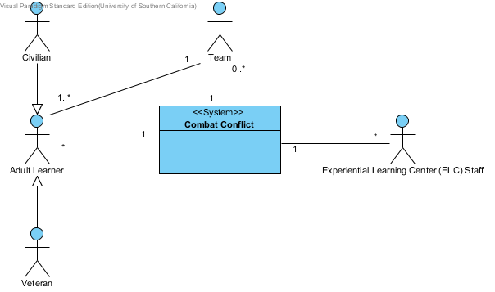
Figure 1: System Context Diagram

Table 1: Actors Summary
Actor | Description | Responsibilities
Adult Learner | People who access the system in order to learn about the skills Combat Conflict provides lessons in. | - Provides basic information about self to system  - Selects a skill to take a quiz on  - Answers all of the questions in the quiz
Civilian | Non-military Adult Learner. | - Select civilian when providing information about self  - Provide data about how civilians react to the situations in the quizzes
Veteran | Military veteran Adult Learner. | - Select veteran when providing information about self  - Provide data about how veterans react to the situations in the quizzes
Team | Group of adult learners doing the team exercise portion of Combat Conflict | - Work together to answer scenario questions  - Present their results after completing all scenarios
ELC staff | Staff running activities that involve combat conflict | - Inserting, editing, or removing quizzes from the system  - Directs what Adult Learners do when at the ELC

Artifacts & Information
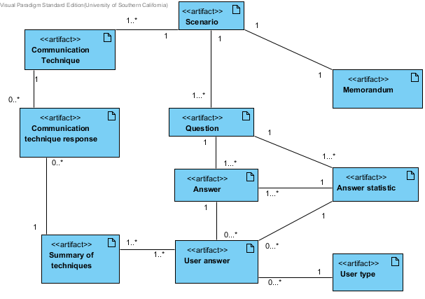
Figure 2: Artifacts and Information Diagram
Table 2: Artifacts and Information Summary
Artifact | Purpose
Scenario | Contains the media and questions a user will view and be asked about for a scenario
Memorandum | Memo describing the scenario
Question | Asks users how they would respond or react to a scenario
Answer | Gives users options to select for a question
Answer Statistic | Holds statistics for a question and its answers regarding how previous users answered
User answer | Answers that users have selected
User type | Whether a user is a civilian or veteran
Communication technique | Task given at end of scenario for team to work through and write up responses for
Communication technique response | A team’s response to the communication technique
Summary of techniques | Summary of answers that team gave throughout exercise to present to other teams

Behavior
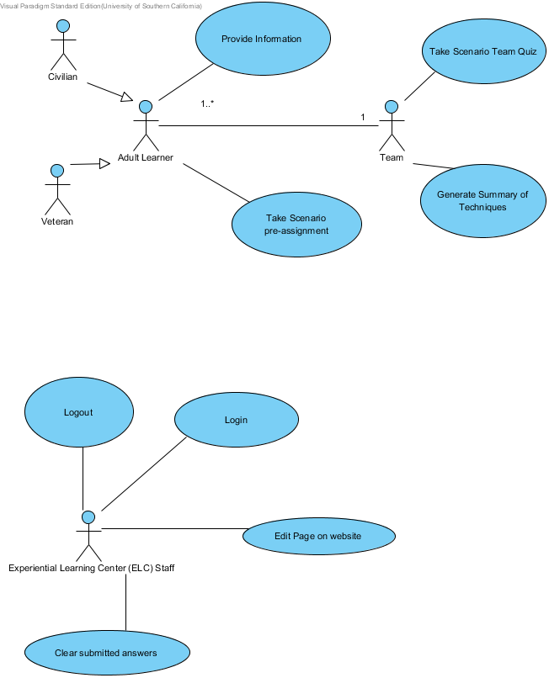
Figure 3: Process Diagram

Provide Information
Table 3: Provide Information Process Description
Identifier | Provide Information
Purpose | Gives system information on if user is civilian or veteran
Requirements | OG-2, OG-3, LOS-3
Development Risks | none
Pre-conditions | User has opened Combat Conflict Website
Post-conditions | User’s information stored as cookie

Table 4: Provide Information Typical Course of Action
Seq# | Actor’s Action | System’s Response
1 | Click on Civilian or veteran radio button
2 | Click Continue button
3 |  | System loads and displays first scenario
Table 5: Provide Information – user does not select any option
Seq# | Actor’s Action | System’s Response
1 | User does not select any radio button
2 | Click Continue button
3 |  | Browser alerts user that they have not selected any option

Take individual pre-assignment
Table 6:Take Scenario quiz Process Description
Identifier | Take individual pre-assignment
Purpose | Give users questions to answer about a scenario in order to populate the system with responses
Requirements | OG-1, OG-2, LOS-3
Development Risks | Users may not take quizzes seriously and just answer randomly
Pre-conditions | User has given system his information
Post-conditions | Responses submitted to server

Table 7: Take individual pre-assignment – normal scenario
Seq# | Actor’s Action | System’s Response
1 | User reads scenario description
2 | User clicks on radio buttons of answers
3 | User clicks continue button
4 |  | Answers from page stored as cookie
5 |  | System loads next scenario
Repeat steps 1-5 for each scenario
6 |  | System stores answers in database
7 |  | System displays thank you message to user

Table 8: Take individual pre-assignment – cookies expire
Seq# | Actor’s Action | System’s Response
1 | User partially completes quiz, answers questions for at least one scenario but not all of them
2 | User tries to continue after cookie expiration time
3 |  | Site gives error saying that user must restart pre-assignment

Take Team Scenario quiz
Table 9: Take Scenario quiz Process Description
Identifier | Take Team Scenario quiz
Purpose | Give team quiz to guide them through working as a team
Requirements | OC-1, OC-2, LOS-1, LOS-2, OG-1, OG-3
Development Risks | Users may not take quizzes seriously and just answer randomly
Pre-conditions | Team has selected scenario
Post-conditions | Answers temporarily saved

Table 10: Take Team Scenario Quiz – normal scenario
Seq# | Actor’s Action | System’s Response
1 | User reads scenario memo
2 | User clicks next
3 | User reads question
4 | User clicks on radio buttons of answers
5 | User clicks continue button
6 |  | Answers from page stored as cookie
7 |  | System loads response statistics page
8 | User views answer statistics
9 | User clicks continue
10 |  | System loads Communication Technique
11 | Users read task
12 | Users give their responses
13 | Click Select another scenario button
14 |  | Answers submitted to system
15 |  | Scenario list loaded, the scenario that has just been completed is not displayed

Table 11: Take Team Scenario Quiz – no answer statistics in database
Seq# | Actor’s Action | System’s Response
Steps 1-6 of normal scenario
7 |  | Displays 0% for each statistic
Steps 9-15 of normal scenario

Logout
Table 12: Logout Process Description
Identifier | Logout
Purpose | Logs ELC staff member out of combat conflict website
Requirements
Development Risks | none
Pre-conditions | ELC staff member logged into combat conflict
Post-conditions | ELC staff member logged out of combat conflict

Table 13: Logout Typical Course of Action
Seq# | Actor’s Action | System’s Response
1 | Click logout button
2 |  | Returns staff member to combat conflict front page

Edit page on website
Table 14: Edit page on website Process Description
Identifier | Edit page on website
Purpose | Lets ELC staff make corrections/modifications to existing pages
Requirements | none
Development Risks | ELC staff may have trouble understanding the editing system
Pre-conditions | ELC staff logged in to website
Post-conditions | Page is updated with ELC edits

Table 15: Edit page- normal scenario
Seq# | Actor’s Action | System’s Response
1 | User selects page to edit
2 | Modifies the text that displays on that page
3 | Clicks update button
4 |  | Displays message saying page has been updated

Table 16: Edit Skill Alternate Course of Action - update fails
Seq# | Actor’s Action | System’s Response
Steps 1-3 of normal scenario
3 |  | Displays error message indicating why the update failed

Clear Submitted Answers
Table 17: Clear submitted answer Process Description
Identifier | Clear Submitted Answers
Purpose | Let’s ELC staff clear answers submitted to database
Requirements | OC-1
Development Risks | ELC staff may accidentally remove answers
Pre-conditions | ELC staff logged into Combat Conflict
Post-conditions | Responses dropped from database

Table 18: Clear Submitted Answers – normal Scenario
Seq# | Actor’s Action | System’s Response
1 | Click on Database button on sidebar
2 |  | Shows database information
3 | Click on Empty/Drop tables button
4 |  | Displays list of tables along with empty/drop buttons next to them
5 | User selects empty for userResponses table
6 |  | Responses deleted from table

Login
Table 19: Login Process Description
Identifier | Login
Purpose | Makes it so only ELC staff are able to change contents of website
Requirements
Development Risks | none
Pre-conditions | User is on combat conflict website and not logged in
Post-conditions | User is on the wp-admin version of the site

Table 20: Login Typical Course of Action
Seq# | Actor’s Action | System’s Response
1 | Enter username and password
2 | Click log in
3 |  | Redirects user to admin version of the site

Table 21: Login Alternate Course of Action: incorrect credentials
Seq# | Actor’s Action | System’s Response
1 | Enter username and password
2 | Click log in
3 |  | Displays error message indicating username/password was incorrect

Modes of Operation

Combat Conflict only operates in one mode

System Analysis Rationale

At this point, the system is clear enough that there is no in-depth explanation needed for any of the components.

Technology-Independent Model

Design Overview

System Structure
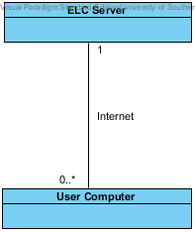
Figure 4: Hardware Component Class Diagram
Table 22: Hardware Component Descriptions
Hardware Component | Description
ELC Server | Experiential Learning Center server being used to host Combat Conflict
User Computer | Computers used to access combat Conflict and perform exercises.

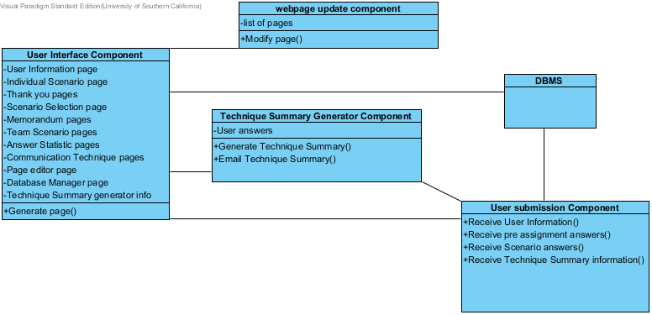Figure 5: Software Component Class Diagram
Table 23: Software Component Description
Software Component | Description
User Interface Component | Stores/Generates web-pages for users of Combat Conflict
Webpage update component | Enables ELC staff to modify pages
Technique Summary Generator Component | Creates Summary Of Techniques for teams and emails them to the address given
User submission component | Handles information submitted by users answering questions
DBMS | Database Management System that stores data used in system

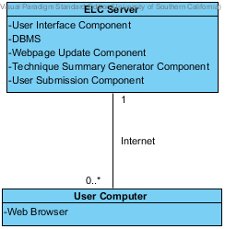
Figure 6: Deployment Diagram

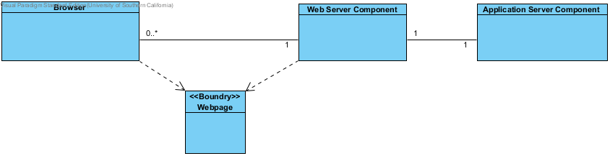Figure 7: Supporting Software Component Class Diagram
Table 24: Supporting Software Component Descriptions
Supporting Software Component | Description
Browser | Internet Browser that connects to Combat Conflict
Webpages | Pages generated by Combat Conflict for user to interact with
Web Server Component | The server component that routes all network traffic and requests between external systems and the application server.
Application Server Component | Server component that Combat Conflict resides on. All the logical computations are done on this component

Design Classes

Design Classes
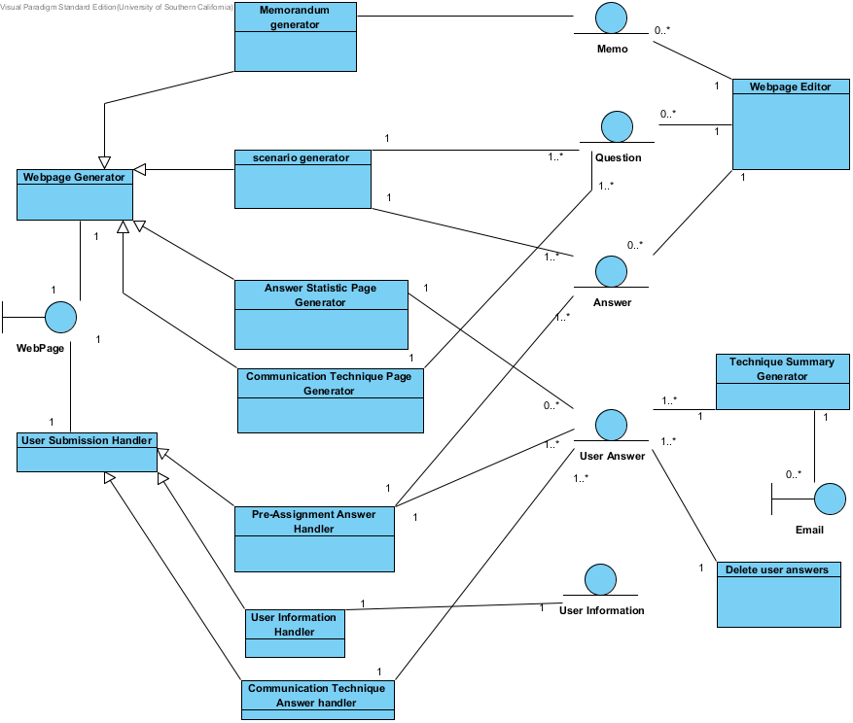Figure 8: Design Class Diagram
Table 25: Design Class Descriptions
Class | Type | Description
WebPage | Boundary | WebPages sent to users to interact with system
Webpage Generator | Component Abstraction | Generic component for classes that generate webpages
User Submission Handler | Component Abstraction | Generic component for handling information sent by users
Memorandum generator | Component | Generates Memo pages
Scenario generator | Component | Generates Scenario pages for quizzes
Answer Statistic Page Generator | Component | Generates pages showing users answer statistics
Communication Technique Page Generator | Component | Generates pages describing a communication technique and questions related to that technique
Pre-assignment answer handler | Component | Handles user responses to pre-assignment questions
User Information Handler | Component | Handles user information submitted during pre-assignment
Communication Technique Answer Handler | Component | Handles user responses to communication technique questions
Memo | Entity | Memo describing scenario
Question | Entity | Questions asked during quizzes
Answer | Entity | Answer choices for questions
User Answers | Entity | Answers that users gave to questions
User Information | Entity | Information about users e.g. veteran status
Webpage Editor | Component | Component to handle modification of webpages
Technique Summary Generator | Component | Generates Summary of Technique for users to present
Email | Boundary | Emails containing summary of techniques
Delete User Answers | Component | Allows ELC staff to delete user answers from database

Process Realization

Figure 9: Process Realization Diagram - Individual pre-assignment
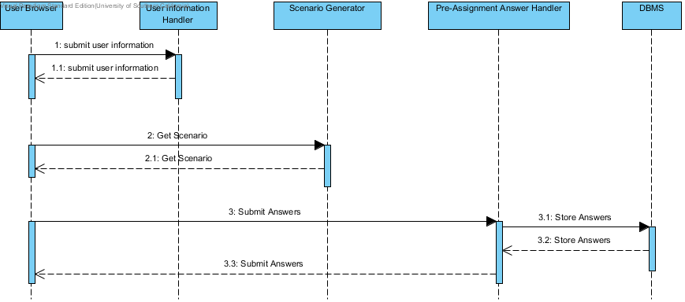
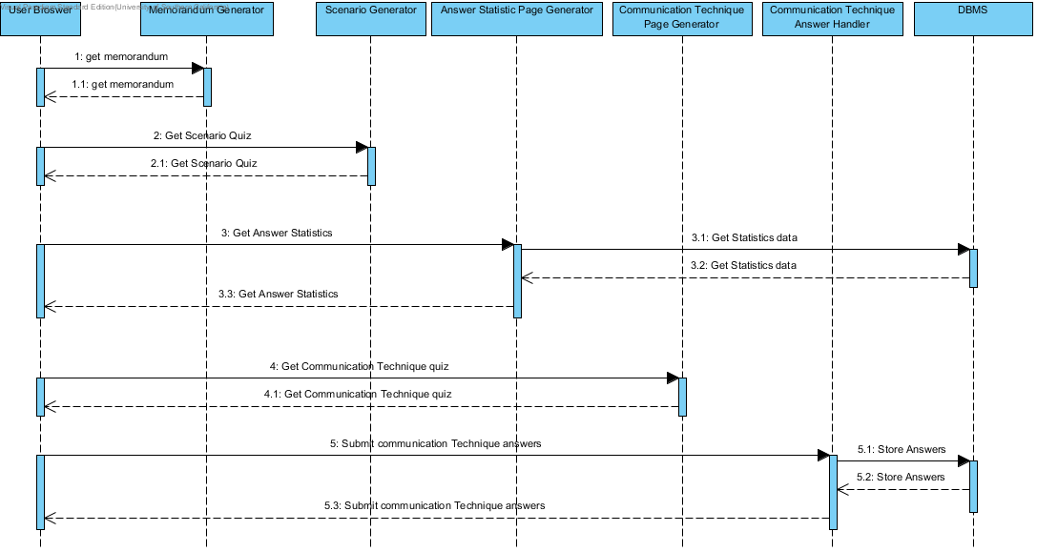
Figure 10: Process Realization Diagram – Team Scenario

Design Rationale
Combat Conflict is for the most part a simple website. Users go there to take quizzes and submit their answers to the system. So our architecture is focused around 2 different tasks generating web pages for users and handling the information submitted by users. In addition to these 2 major tasks, there is the occasional use of the system by the ELC staff to maintain the website. All of these parts of the system interact with a database through a DBMS to get/store data. Overall our system is a client/server architecture
These components make for 4 primary types of components running in our system
- Webpage generation
- User submission handling
  - Responses to questions
  - Sending emails
- Website Maintenance
  - Modifying pages
  - Pruning tables
- DBMS

As this is a one semester project, we are using COTS for the framework of the entire system. With the COTS we are using, we make the website according to our client’s specifications. Using COTS for the website framework allowed us to get a prototype up and have core functionality ready so that we could show the website to the client early on.
We showed the sequence diagrams for the Individual pre-assignment and the team scenario because these are the 2 main use-cases of our assignment.

Technology-Specific System Design

Design Overview

System Structure
Figure 11: Hardware Component Class Diagram
Table 26: Hardware Component description
Hardware Component | Description
ELC Server | Experiential Learning Center server being used to host Combat Conflict
User Computer | Computers used to access combat Conflict and perform exercises.

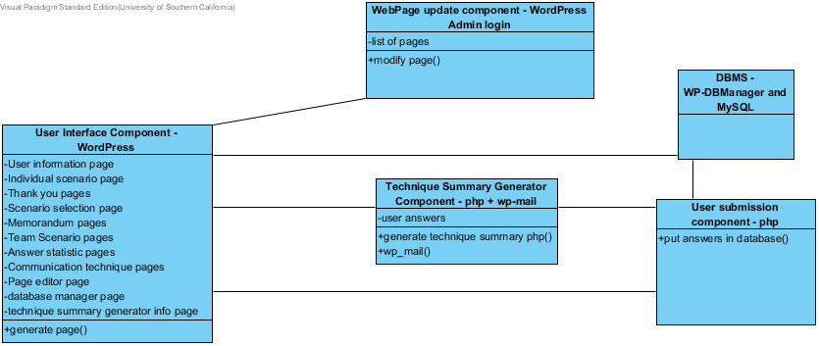Figure 12: Software Component Class Diagram
Table 27: Software Component description
Software Component | Description
User Interface Component | We use WordPress to generate the web pages shown to users
Webpage update component | Logging into WordPress as an admin allows a user to edit page
Technique Summary Generator Component | Php is used to generate an email from the answers users have given and wp_mail sends it
User submission component | Php code on each page handles storing of answers in database
DBMS | MySQL serves as back end DBMS and WP-DBManager serves as abstraction for ELC staff looking at database

Figure 13: Deployment Diagram

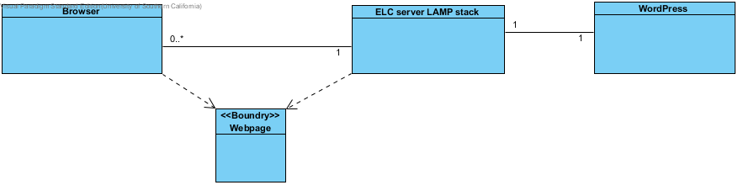Figure 14: Supporting Software Component Class Diagram
Table 28: Supporting software component descriptions
Supporting Software Component | Description
Browser | Internet Browser that connects to Combat Conflict
Webpages | Pages generated by Combat Conflict for user to interact with
ELC server LAMP stack | Linux, Apache, MySQL, PHP. Serves as core software of server running WordPress and handles web access
WordPress | Framework for Combat Conflict website that handles web page storage and generation

Design Classes

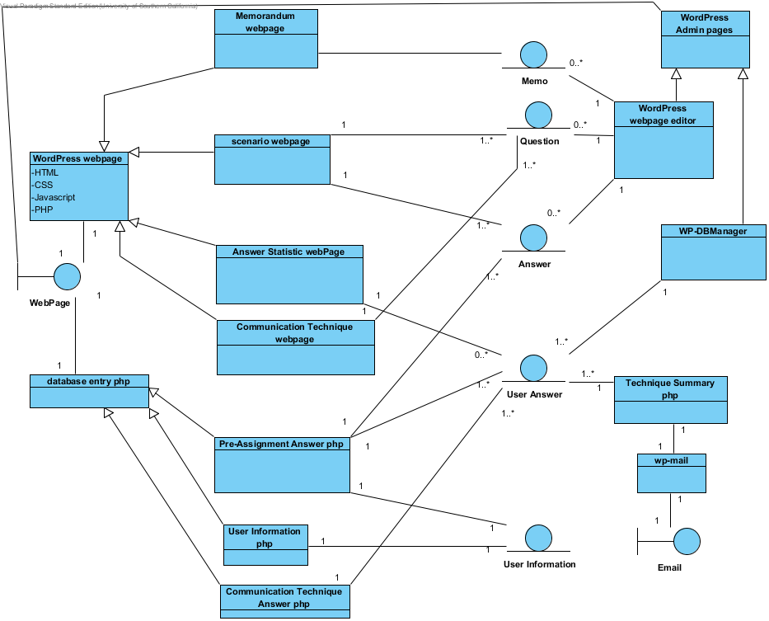Figure 15: Design Class Diagram
Table 29: design class descriptions
Class | Type | Description
WebPage | Boundary | WebPages sent to users to interact with system
WordPress webpage | Component Abstraction | Abstraction of a WordPress webpage that uses HTML/CSS, Javascript, and PHP to create itself
Database entry php | Component abstraction | Abstraction of php used to handle data submitted by user
Memorandum webpage | Component | Page showing memo for a scenario
Scenario webpage | Component | Page showing questions and answer choices for a scenario
Answer statistic webpage | Component | Page showing statistics on who chose what answers for a scenario
Communication technique webpage | Component | Webpage describing a communication technique and asking questions about it
Pre-assignment answer php | Component | Php for submitting the answers to pre-assignment questions
User information php | Component | Php for storing user information
Communication technique answer php | Component | Php for submitting answers to communication technique questions
Memo | Entity | Memo describing scenario
Question | Entity | Questions asked during quizzes
Answer | Entity | Answer choices for questions
User Answers | Entity | Answers that users gave to questions
User Information | Entity | Information about users e.g. veteran status
WordPress admin pages | Component abstraction | Abstraction for pages only people with admin access to the website are able to see
WordPress webpage editor | Component | Wordpress pages for admins to modify the pages normal users see
WP-DBManager | Component | WordPress plugin that allows admins to view and edit the contents of the database
Technique Summary php | Component | Php that generates emails containing a summary of techniques
Wp-mail | Component | Wordpress component that sends emails
Email | Boundary | Emails containing summary of techniques

Process Realization
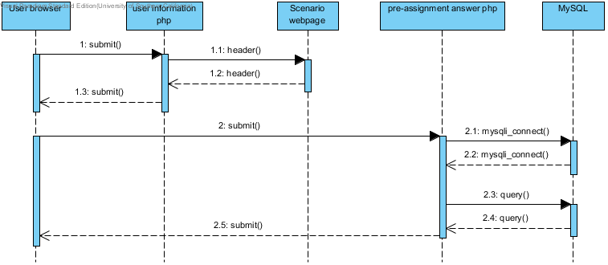
Figure 16: Process Realization Diagram - Individual exercise
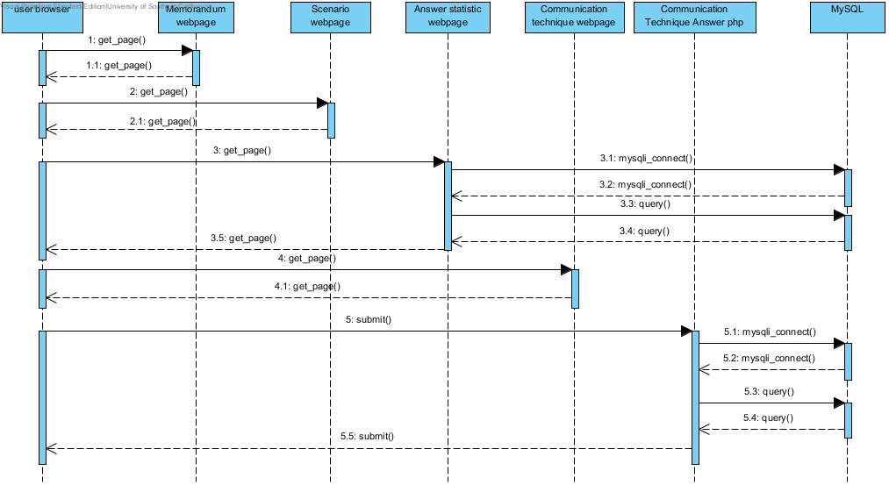
Figure 17: Process Realization Diagram - team exercise

Design Rationale

Since section 3.2 already gave the rationale for the overall architecture, this section will be about why we used the different components we used for each of the 4 sections of the system; webpage generation, user submission handling, website maintenance, and DBMS
Using WordPress as the framework of the website allowed us to develop quickly since it is made to be used easily even by users with little web development experience. It has a large library of plugins to assist us in development and its large user base also means that there are many resources to help us in development. It has been an easy way to keep our various web pages organize and it has provided us with tools to build those web pages. The admin version of the website is also an easy way for maintainers to make adjustments to the website after we hand it over.
Our system does not require very much back-end work to generate websites and handle user data submissions, and PHP was enough to get that work done. Most of the back end operations are related to database access; submitting data to it and getting data from it. Both of these are well supported in PHP and could be easily embedded into web pages in WordPress.
We showed the individual pre-assignment and team exercise again in the sequence diagram because they are the main use-cases for the system.

Architectural Styles, Patterns and Frameworks
Table 30: Architectural Styles, Patterns, and Frameworks
Name | Description | Benefits, Costs, and Limitations
Client/Server | This style separates a system into 2 components. Clients make requests to the server in order to get, change, or add information from/to the server. | This style allows for a system to be used from many locations as the client application is usually a lightweight program or a webpage that accesses the server. It also allows for a high level of access control since the server makes all the decisions on who is allowed to do what. However because the server is doing all of the real work, it can be difficult to scale up with increasing amounts of clients making requests.
WordPress | WordPress is a website framework based on PHP and MySQL that is used to build websites. | WordPress is quite simple for anyone to learn how to use, making it easy for anyone to quickly make a website. It has a large plugin and theme library that lets users change the look and functionality of the websites they make. The main disadvantage of WordPress is that modifying those pre-built components can be difficult. Depending on how complicated they are, they can require a lot of web development knowledge that negates the easy to use benefit of WordPress.

